React.dev – for reference material

INSTALLATION STEPS:
INSTALL NODEJS LATEST FOR WINDOWS
Verify: command –> node -v
INSTALL VSCODE EDITOR
Create a folder say D:\Reactcourse drag and drop it onto vscode editor
In the editor -> Reactcourse -> new file -> say readme.md
Type following code
# start of react js -> top right corner -> preview

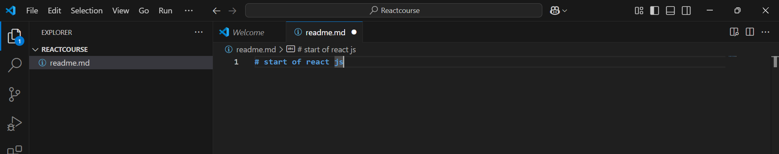

Why you need hooks and project

Create a new project 02project

npm create vite@latest

React -> Javascript

Cd 02project
npm install
npm run dev

Go to App.jsx

Type the following:
import { useState } from 'react'

import './App.css'

function App() {
let counter=15

const addValue = () => {
counter = counter +1
console.log(counter) /*check the output in console – inspect */
}

return (
<>
<h1>React Project 02 {counter}</h1>
<h2>Counter Value: {counter}</h2>
<button
onClick={addValue}
>Add Value</button>{" "}
<button>Remove Value</button>
<p>Footer: {counter}</p>
</>
)
}

export default App

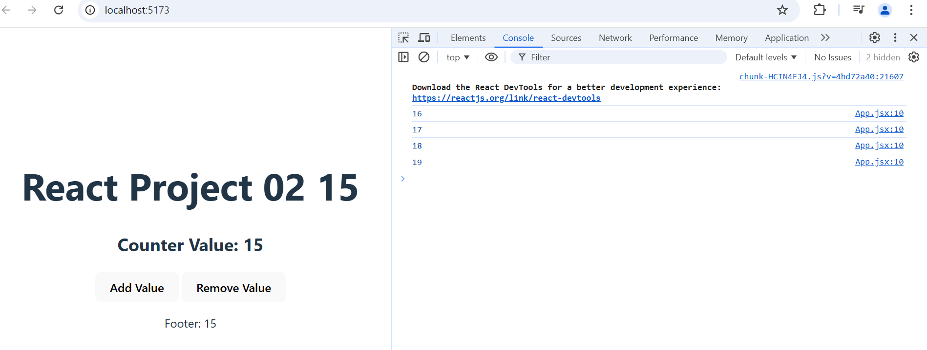

We observe that even when we click on Add value the counter Value on web page is not updated but in background console it shows updated value.

function App() {

const [counter, SetCounter] = useState(15)
/* counter is a variable and SetCounter is a fn */
/* initial value of counter is 15*/
const addValue = () => {
SetCounter(counter+1)
console.log(counter)
}
return (
<>
<h1>React Project 02 {counter}</h1>
<h2>Counter Value: {counter}</h2>
<button
onClick={addValue}
>Add Value</button>{" "}
<button>Remove Value</button>
<p>Footer: {counter}</p>
</>
)
}

import { useState } from 'react'
import './App.css'
function App() {
const [counter, SetCounter] = useState(15)
/* counter is a variable and SetCounter is a fn */
/* initial value of counter is 15*/

const addValue = () => {
SetCounter(counter+1)
console.log(counter)
}

const subValue = () => {
const newcounter = counter-1
SetCounter(newcounter)
console.log(counter)
}
return (
<>
<h1>React Project 02 {counter}</h1>
<h2>Counter Value: {counter}</h2>
<button
onClick={addValue}
>Add Value</button>{" "}
<button
onClick={subValue}
>Remove Value</button>
<p>Footer: {counter}</p>
</>
)
}
export default App

NOTE:
const addValue = () => { //call back function definition
SetCounter(counter+1)
SetCounter(counter+1)
SetCounter(counter+1)
SetCounter(counter+1)
}

BUT STILL WHEN YOU CLICK ON BUTTON IT INCREMENTS BY ONLY ONCE… THIS IS BECAUSE REACT WILL CONSIDER THE FUNCTION CALL ONLY ONCE (BATCH FUCNTION CALLS ON SAME VARIABLE). HENCE WE NEED TO MODIFY IT AS FOLLOWS:
const addValue = () => {
SetCounter((preCounter) => preCounter+1)
SetCounter((preCounter) => preCounter+1)
SetCounter((preCounter) => preCounter+1)
SetCounter((preCounter) => preCounter+1)
}

Virtual DOM, Fibre and reconciliation

What is reconciliation?

Reconciliation in React is the process by which React updates the DOM to match the desired state of the user interface. When the state or props of a component change, React determines how to efficiently update the UI by comparing the new virtual DOM with the previous one. This process involves the following key steps:
1. Virtual DOM Representation
React uses a lightweight representation of the actual DOM, called the virtual DOM. When a component's state or props change, React creates a new virtual DOM tree.
2. Diffing Algorithm
React compares the new virtual DOM tree with the previous one using its diffing algorithm. The algorithm is optimized to detect changes efficiently by:
- Comparing elements at the same level in the tree.
- Reusing elements that haven’t changed.
- Detecting when elements are added, removed, or reordered.
3. Minimal Updates
After identifying the differences between the old and new virtual DOMs, React calculates the minimal set of updates needed to bring the real DOM in sync with the virtual DOM.
4. Batching Updates
React batches multiple state updates to minimize the number of re-renders and DOM manipulations, which improves performance.
5. Commit Phase
In the commit phase, React applies the calculated updates to the actual DOM.

Why is Reconciliation Important?
- Performance: Manipulating the DOM directly is expensive. React minimizes DOM manipulations by determining and applying only the necessary updates.
- Consistency: React ensures the UI remains predictable and consistent with the state and props.

Common Scenarios in Reconciliation
- Key Prop: React uses key props to track elements in lists. Providing stable and unique keys improves reconciliation performance when list items are added, removed, or reordered.
- Component Type: React assumes that elements of the same type with the same key are the same and reuses them, avoiding unnecessary re-renders.
Understanding reconciliation helps developers optimize React applications by writing components that React can efficiently reconcile.

What is a Fiber in React:

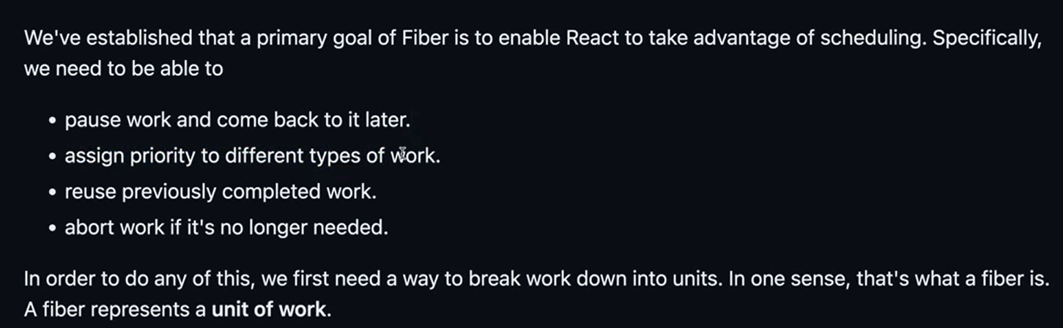

In React, Fiber is the reconciliation engine introduced with React 16. It is a complete reimplementation of React’s core algorithm to improve performance and flexibility. Fiber enables React to handle updates more efficiently and supports advanced features such as time slicing and concurrent rendering.
Key Features and Uses of Fiber in React:

1. Enables Concurrent Rendering
- What it does: Fiber allows React to break rendering work into chunks and prioritize updates based on their importance.
- Why it’s useful: This ensures that high-priority updates, like user interactions or animations, are processed quickly, without being blocked by less urgent updates.
Example: When typing in an input box, the UI can remain responsive even if a large component tree is rendering.

2. Time-Slicing
- What it does: React Fiber divides rendering work into small units of work that can be paused, resumed, or discarded.
- Why it’s useful: This ensures that React doesn't block the main thread for too long, improving performance for applications with heavy computations or animations.

3. Better Scheduling
- What it does: Fiber introduces a scheduler that assigns priority levels to different tasks (e.g., rendering, updating).
- Why it’s useful: Critical updates, like user interactions, are prioritized over background tasks, improving responsiveness.

4. Supports Suspense and React Lazy
- What it does: Fiber enables features like Suspense and React.lazy, allowing developers to split their code and load components dynamically when needed.
- Why it’s useful: It reduces the initial load time and improves the user experience by loading only what’s necessary.

5. Error Handling
- What it does: Fiber introduces improved error boundaries, allowing React to recover gracefully from rendering errors without crashing the entire app.
- Why it’s useful: This leads to more resilient applications.

6. Animation and Gesture Support
- What it does: Fiber’s ability to pause and prioritize rendering helps with smoother animations and gesture-based interactions.
- Why it’s useful: It ensures smooth, frame-perfect animations even under heavy workloads.

7. Backwards Compatibility
- What it does: Fiber is designed to be backward-compatible with React’s existing APIs.
- Why it’s useful: Developers can take advantage of Fiber’s features without needing to rewrite their applications.

Conclusion:
React Fiber is a powerful upgrade to React’s rendering system that enhances performance, enables advanced features like concurrent rendering, and improves the user experience. It makes React applications more responsive, efficient, and capable of handling modern UI challenges.

Tailwind and Props in React JS

create a new project say 03tailwindprops
npm create vite@latest
Choose React -> JavaScript
cd 03tailwindprops
npm install
npm run dev

Step 1: Install Tailwindcss

https://tailwindcss.com/docs/installation/using-vite

make sure you are inside project say 03tailwindprops.

npm install tailwindcss @tailwindcss/vite

vite.config.js

import { defineConfig } from 'vite'
import tailwindcss from '@tailwindcss/vite'
export default defineConfig({
plugins: [
tailwindcss(),
],
})

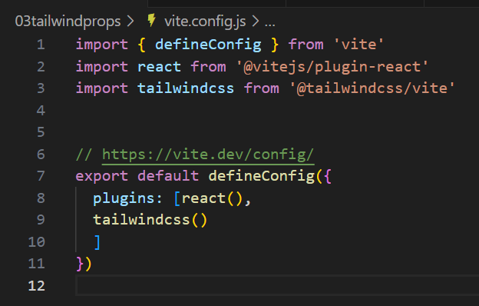

@import "tailwindcss";

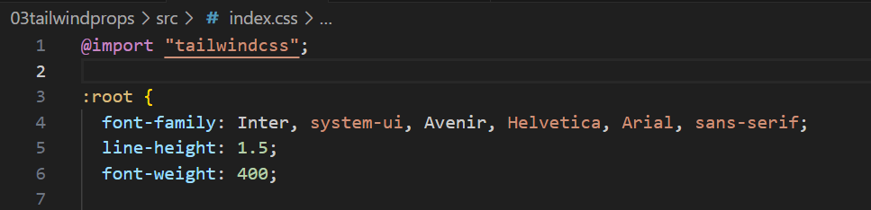

npm run dev

Extension -> Search -> Tailwind CSS IntelliSense -> Install

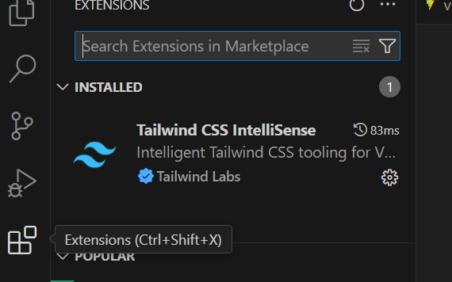

https://tailwindcss.com/docs/installation/using-vite
App.css
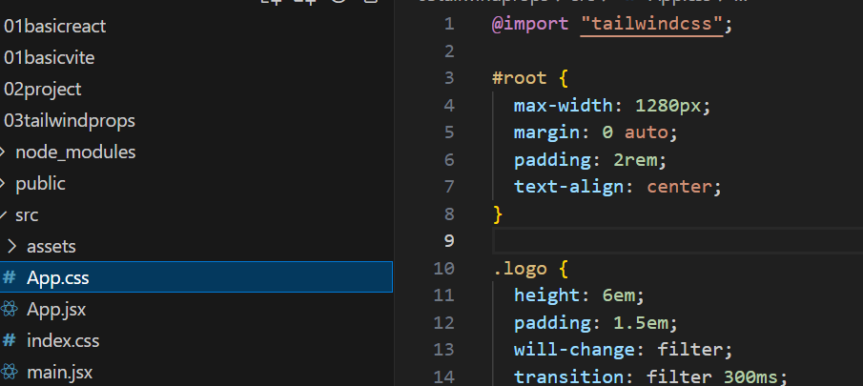

App.jsx
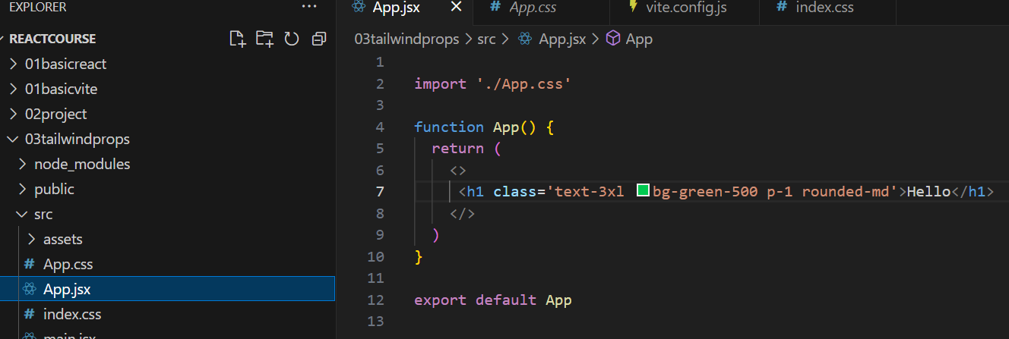

Index.css
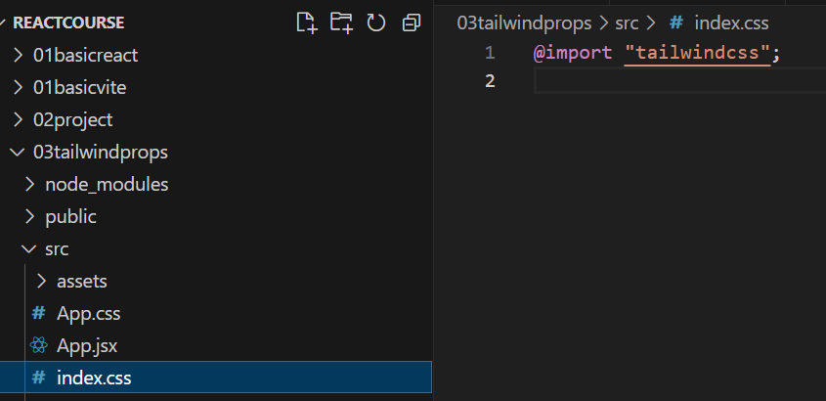
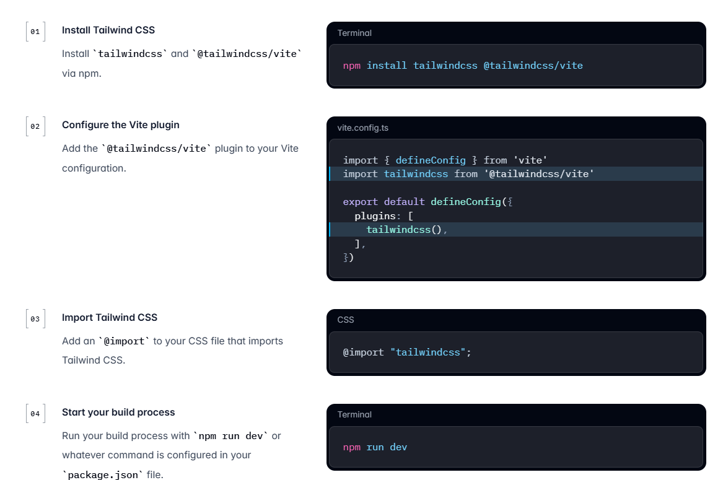

Props (Properties)

Step 1: Create a new file named Card.jsx either inside Assets folder directly or else to organize in a better way create a folder called Components inside Assets folder and then create a file named Card.jsx

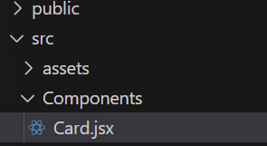

Go to – Extension - Install - ES7+ React/Redux/React-Native snippets

Rafce – gives a ready react arrow function

Rfce – gives a ready react function

Card.jsx

import React from 'react'
function Card()
{
return (
<div>
<div className="flex flex-col items-center gap-6 p-7 md:flex-row rounded-2xl">
<div>
<img className="size-48 shadow-xl rounded-md" alt="" src="img1.jpg" />
</div>
<div className="flex items-end md:items-start">
<span className="text-2xl font-medium">Class Warfare</span>
<span className="font-medium text-sky-500">The Anti-Patterns</span>
</div>
</div>
</div>
)
}
export default Card

App.jsx

import './App.css'
import Card from './Components/Card'

function App() {
return (
<>
<h1 className='text-3xl bg-green-500 p-1 rounded-b-full text-yellow-600'>Hello</h1>
<Card/>
<Card/>
<Card/>
</>
)
}
export default App

Now modify the App.jsx as follows:

import './App.css'
import Card from './Components/Card'
function App() {
return (
<>
<h1 className='text-3xl bg-green-500 p-1 rounded-b-full text-yellow-600'>Hello</h1>
<Card username=’Roshan’/>
<Card/>
<Card/>
</>
)
}
export default App

Card.jsx
function Card(props)
{
return (
<div>
<div className="flex flex-col items-center gap-6 p-7 md:flex-row rounded-2xl">
<div>
<img className="size-48 shadow-xl rounded-md" alt="" src="img1.jpg" />
</div>
<div className="flex items-end md:items-start">
<span className="text-2xl font-medium">{props.username}</span>
<span className="font-medium text-sky-500">The Anti-Patterns</span>
</div>
</div>
</div>
)
}
export default Card

Note:
function Card({username})
{
…
<span className="text-2xl font-medium">{username}</span>
}

function Card({username='Default'})
{
..
}

If you don’t pass any value (Default value)

Multiple parameter passing…

<Card username='Roshan' post='Professor'/>

Receiving multiple parameters:

function Card({username='Default', post='Not yet assigned'})
{
<span className="text-2xl font-medium">{username}</span>
<span className="font-medium text-sky-500">{post}</span>
}

Calling in App.jsx

<Card username='Roshan' post='Professor'/>
<Card username='Akash' post='Software Engineer'/>
<Card username='Kiran' post='Manager'/>

Passing Object:

import './App.css'
import Card from './Components/Card'

function App() {
let myObj={
place: 'Nitte',
city: 'Karkala',
state: 'Karnataka',
}

return (
<>
<h1 className='text-3xl bg-green-500 p-1 rounded-b-full text-yellow-600'>Hello</h1>
<Card username='Roshan' post={myObj}/>
<Card username='Akash' post='Software Engineer'/>
<Card username='Kiran' post='Manager'/>
</>
)
}

function Card({username='Default', post})
{
…
<span className="text-2xl font-medium">{username}</span>
<span className="font-medium text-sky-500">{post.place}{" "}{post.city}</span>
}

Building a react project | bgChanger

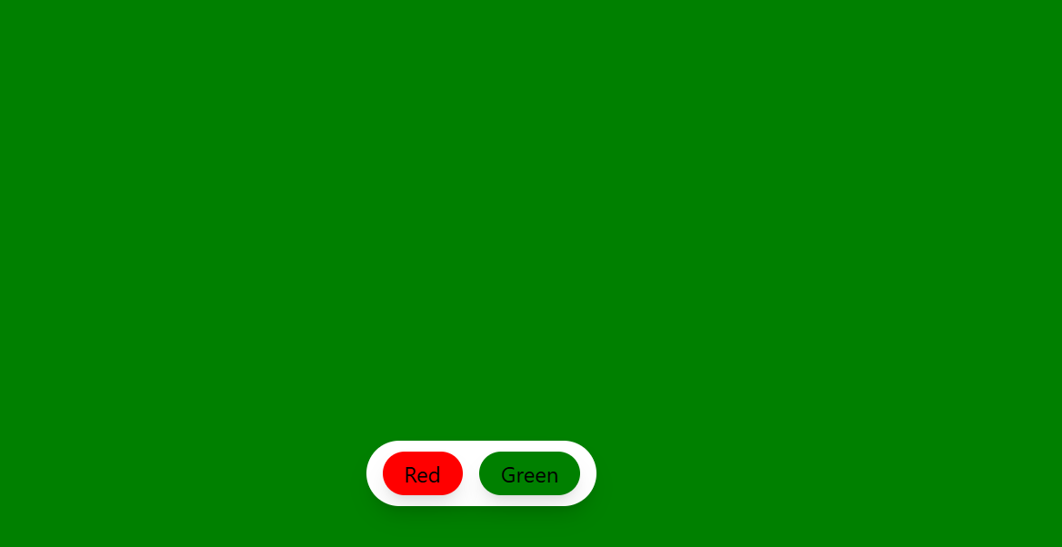
https://www.youtube.com/watch?v=Tu9_vmzEK9w&list=PLRAV69dS1uWQos1M1xP6LWN6C-lZvpkmq&index=9

Create a new vite project:
npm create vite@latest

..

Install tailwindcss
npm install tailwindcss @tailwindcss/vite

Vite.config.js

import { defineConfig } from 'vite'
import react from '@vitejs/plugin-react'
import tailwindcss from '@tailwindcss/vite'

// https://vite.dev/config/
export default defineConfig({
plugins: [react(), tailwindcss()],
})

//PROJECT – BACKGROUND COLOR CHANGER
import { useState } from 'react'
import './App.css'

function App() {
const [color, setColor] = useState('Olive')

function changeColor(color){
setColor(color)
}

return (
<div className='w-full h-screen duration-200' style={{backgroundColor:color}}>
<div className='fixed flex flexwrap justify-center bottom-12 inset-x-0 px-2'>
<div className='flex flexwrap justify-center gap-3 shadow-lg bg-white px-3 py-2 rounded-3xl'>
<button
className='outline-none px-4 py-1 rounded-full shadow-lg text-black' onClick={() => changeColor('red')}
>Red</button>
<button
className='outline-none px-4 py-1 rounded-full shadow-lg text-black' onClick={() => changeColor('green')}>Green</button>
</div>
</div>

</div>

)
}

export default App

NOTE: TO GET FULL SCREEN OUTPUT-> GO TO APP.CSS -> SELECT ALL AND DELETE

ANOTHER WAY OF CALLING FUNCTION
import { useState } from 'react'
import './App.css'
function App() {
const [color, setColor] = useState('Olive')
return (
<div className='w-full h-screen duration-200' style={{backgroundColor:color}}>
<div className='fixed flex flexwrap justify-center bottom-12 inset-x-0 px-2'>
<div className='flex flexwrap justify-center gap-3 shadow-lg bg-white px-3 py-2 rounded-3xl'>
<button
className='outline-none px-4 py-1 rounded-full shadow-lg text-black' onClick={() => setColor('red')}
>Red</button>
<button
className='outline-none px-4 py-1 rounded-full shadow-lg text-black' onClick={() => setColor('green')}>Green</button>
</div>
</div>

</div>
)
}
export default App

<button
className='outline-none px-4 py-1 rounded-full shadow-lg text-black' style={{backgroundColor:'red'}} onClick={() => setColor('red')}
>Red</button>
<button
className='outline-none px-4 py-1 rounded-full shadow-lg text-black' style={{backgroundColor:'green'}} onClick={() => setColor('red')}onClick={() => setColor('green')}>Green</button>

useEffect, useRef and useCallback with 1 project in Reactjs

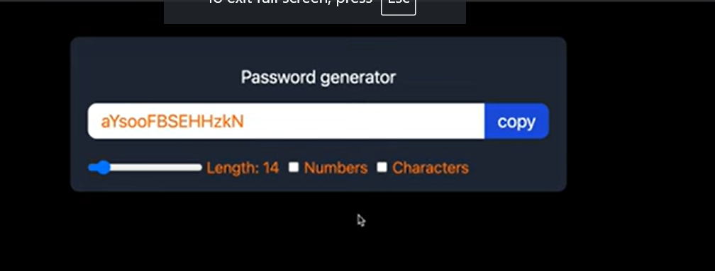

Create a new vite project:
npm create vite@latest
..
Install tailwindcss
npm install tailwindcss @tailwindcss/vite

Vite.config.js

import { defineConfig } from 'vite'
import react from '@vitejs/plugin-react'
import tailwindcss from '@tailwindcss/vite'

// https://vite.dev/config/
export default defineConfig({
plugins: [react(), tailwindcss()],
})

@import "tailwindcss";
Copy to Index.css and delete all other contents.

Open App.jsx file and type following code to test if Tailwind CSS works or not:
import { useState } from 'react'
import './App.css'
function App() {
const [count, setCount] = useState(0)
return (
<>
<h1 className='text-3xl bg-green-400'>password Generator Application</h1>
</>
)
}
export default App

if you get following output, then the tailwind css is working fine.

import { useCallback, useState, useEffect, useRef} from 'react'
import './App.css'

function App() {
const [length, setLength] = useState(8)
const [numberAllowed, setNumberAllowed] = useState(false)
const [charAllowed, setCharAllowed]=useState(false)
const [password, setPassword]=useState('')

const generatePassword = useCallback(() => {
let pass=""
let str="ABCDEFGHIJKLMNOPQRSTUVWXYZabcdefghijklmnopqrstuvwxyz"

if(numberAllowed){
str+='0123456789'
}
if(charAllowed){
str+='!@#$%^&*()_+-'
}
for(let i=1; i<=length; i++){
const pos=Math.floor(Math.random()*str.length+1)
pass+=str.charAt(pos)
}
setPassword(pass)
}, [length, numberAllowed, charAllowed])

useEffect(()=>{
generatePassword()
}, [length, numberAllowed, charAllowed])

const passwordRef=useRef(null)

const copyPasswordClipboard = ()=>{
window.navigator.clipboard.writeText(password)
passwordRef.current.select()
}

return (
<div className='w-full max-w-md mx-auto shadow-md rounded-lg px-4 py-3 my-8 bg-gray-800 text-orange-500'>
<h1 className='text-white text-center my-3 '>Password generator</h1>
<div className='flex shadow rounded-lg overflow-hidden mb-4'>
<input
type='text'
value={password}
className='outline-none w-full px-3 py-1 text-black bg-white'
placeholder='password'
readOnly
ref={passwordRef}
/>
<button
className='outline-none bg-blue-700 text-white px-3 py-0.5 shrink-0'
onClick={copyPasswordClipboard}>Copy</button>
</div>
<div className='flex-col text-sm gap-x-2'>
<div className='flex items-center gap-x-1'>
<input
type='range'
min={6}
max={100}
name=''
id=''
value={length}
className='cursor-pointer'
onChange={(e) => setLength(e.target.value)}
>
</input>
<label htmlFor='length'>Length: {length}</label>
<input
type='checkbox'
defaultChecked={numberAllowed}
onChange={()=>{setNumberAllowed((prev)=>!prev)}}
>
</input>
<label htmlFor='Number'>Number:</label>
<input
type='checkbox'
defaultChecked={charAllowed}
onChange={()=>{setCharAllowed((prev)=>!prev)}}
>
</input>
<label htmlFor='Char Input'>Character:</label>
</div>
</div>
</div>
)
}

export default App

